Index
S.N | LAB Problems | Date | Signature
1 | Write program to implement Monte Carlo’s simulation | 2082/02/15
2 | Write program to implement queuing system and calculate different queue parameters. | 2082/02/15
3 | Write program to implement markov chain | 2082/02/20
4 | Write program generate random number using linear congruential method | 2082/02/20
5 | Write program generate random number using multiplicative congruential method. | 2082/02/20
6 | Write program generate random number using mid square method. | 2082/02/23
7 | Write program to implement KS-test | 2082/02/23
8 | Write program to implement autocorrelation test | 2082/02/24
9 | Write program to implement Chi-Square test | 2082/02/24
10 | Write program to implement gap test | 2082/02/24
11 | GPSS program:  - Joe's Barbershop (Event Driven)  - Joe's Barbershop (Time Driven)  - Manufacturing shop  - Three Inspector Inspection  - Manufacturing shop model 4 | 2082/02/25

Output of GAP Test:
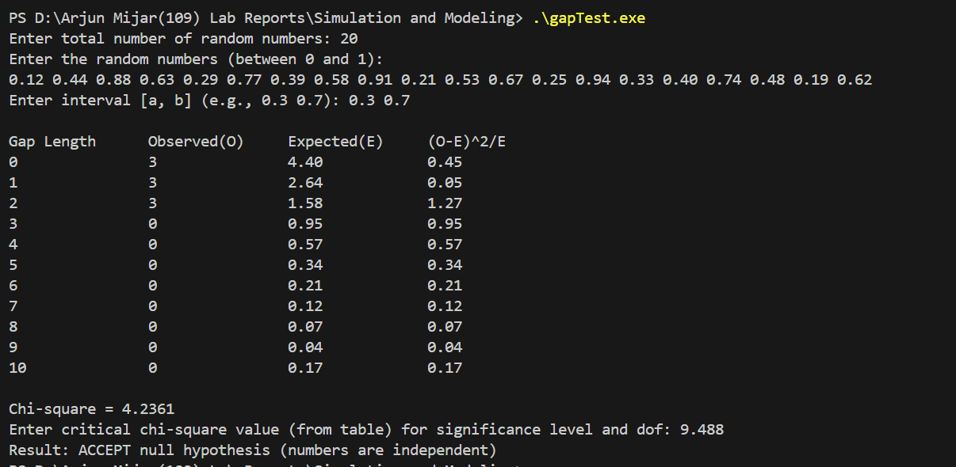

Output of Monte Carlo's Simulation:

Output of Queuing System
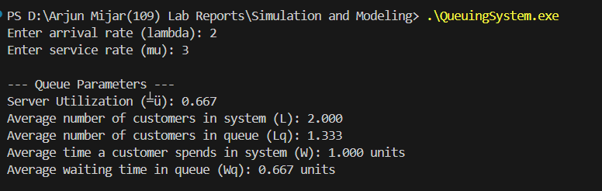

Output of Markov Chain:
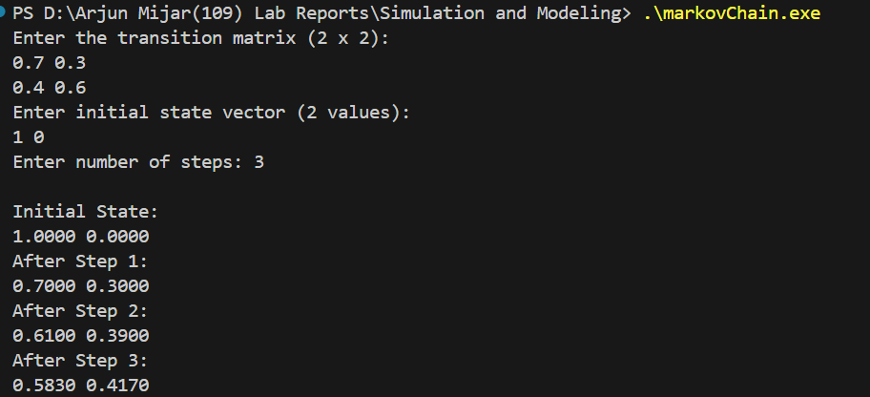

Output of Linear Congruential Method:
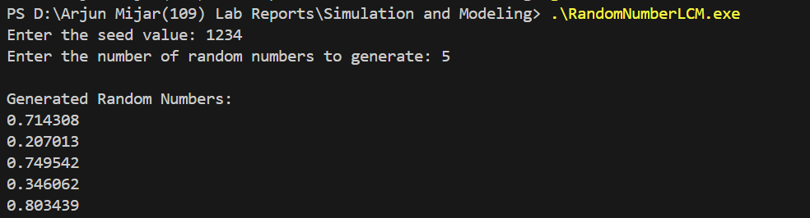

Output of Multiplicative Congruential Method:
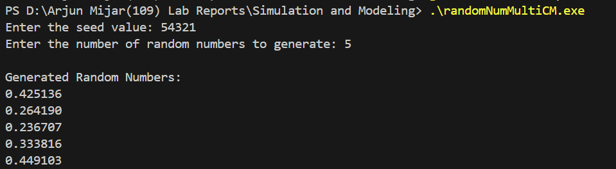

Output of Mid-Square Method:
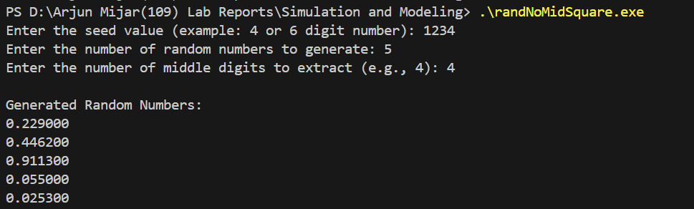

Output of Kolmogorov-Smirnov (KS) Test:
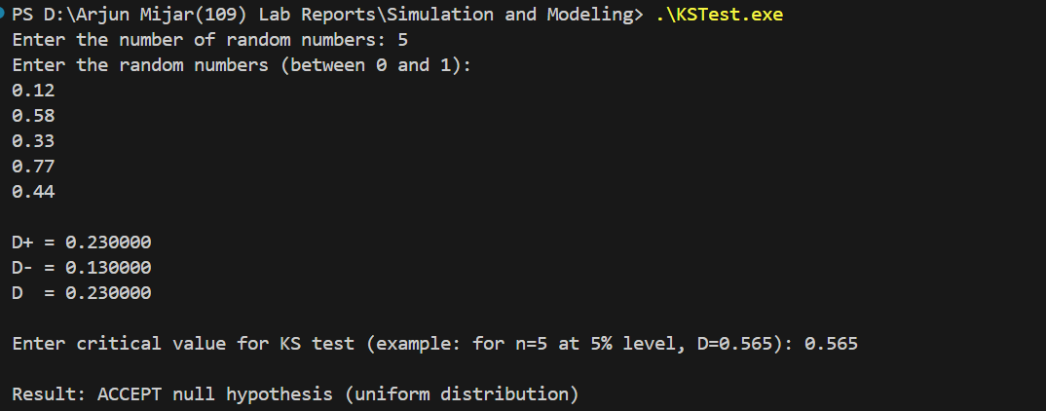

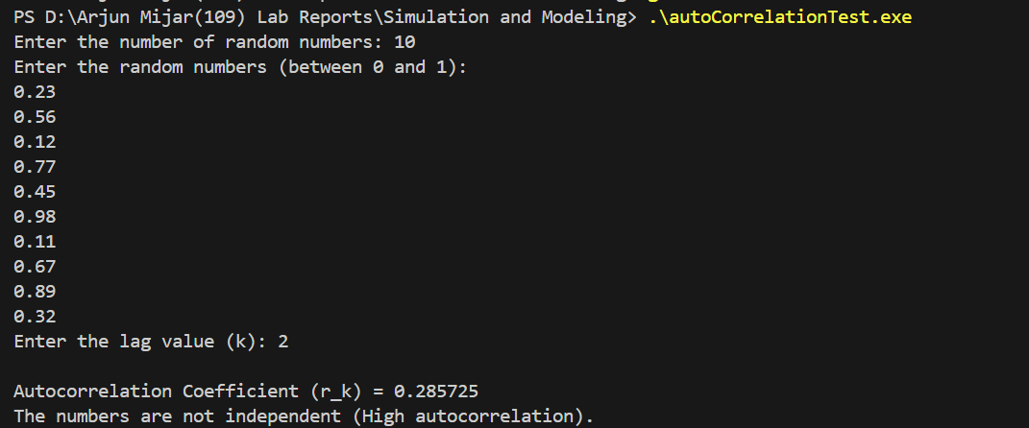
Output of Autocorrelation Test:

Output of Chi-Square Test:
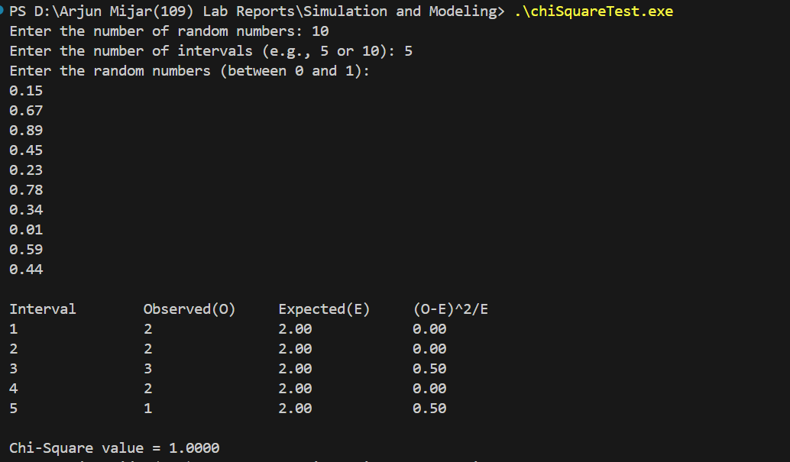

- i) Joe's Barbershop (Event Driven)
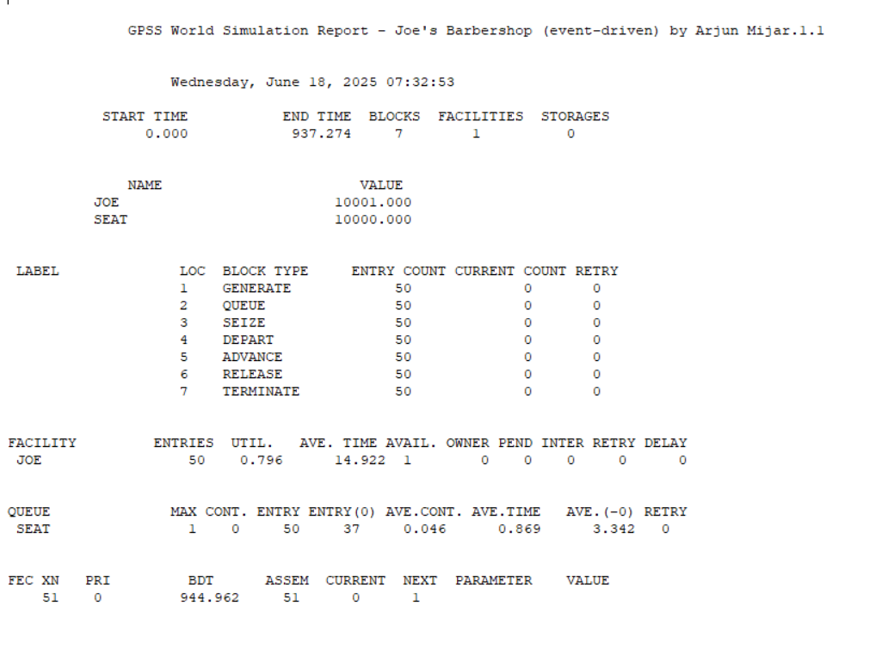
ii) Joe's Barbershop (Time-Driven)
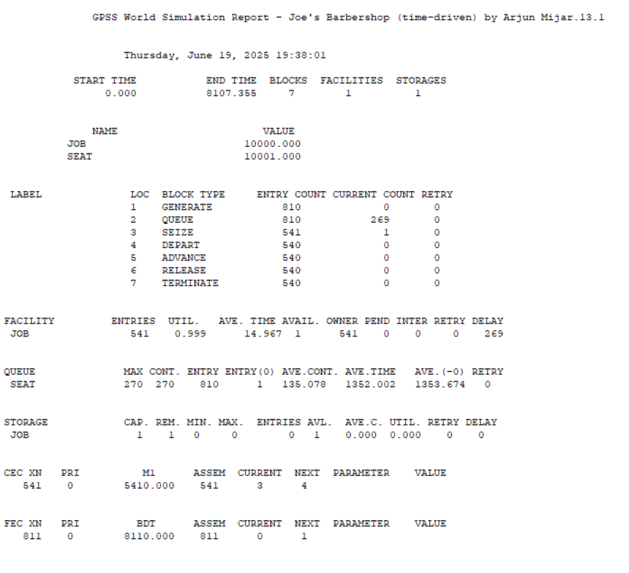

iii) Manufacturing shop
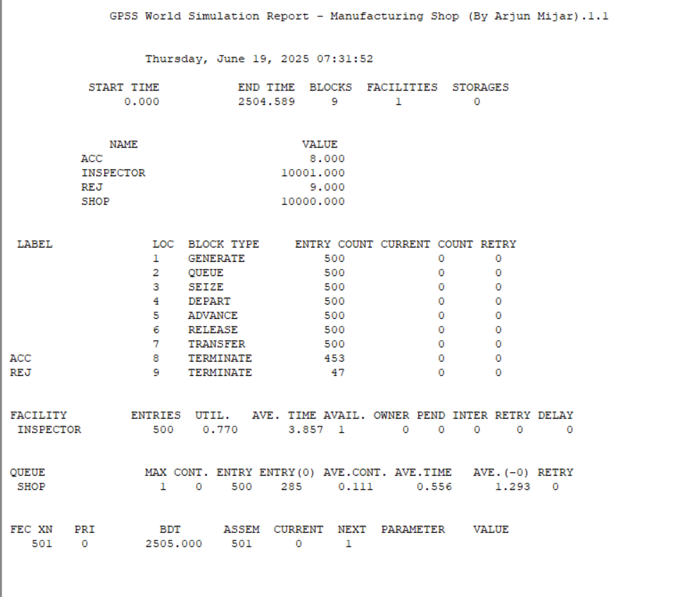

iv) Three Inspector Inspection
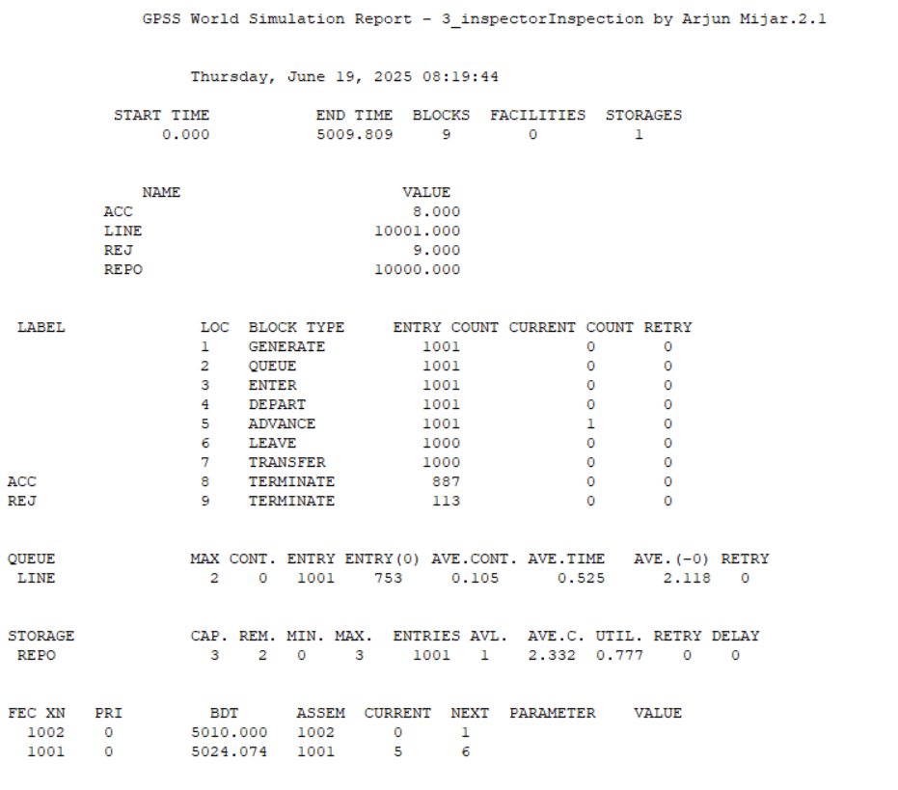

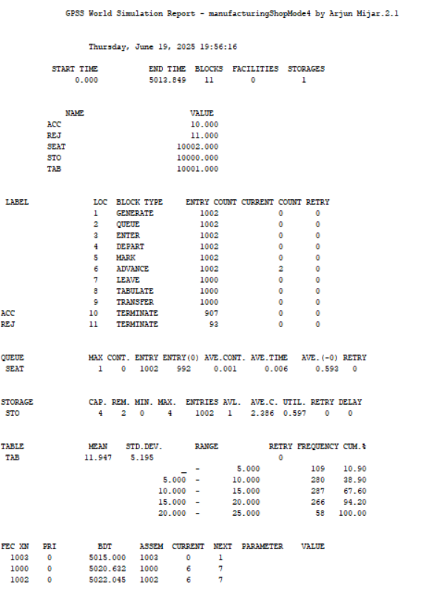
v) Manufacturing shop model 4

